2a)A close up of text on a black background

Description generated with high confidence

2b and c)

A screenshot of text

Description generated with very high confidence

A screenshot of a cell phone

Description generated with very high confidence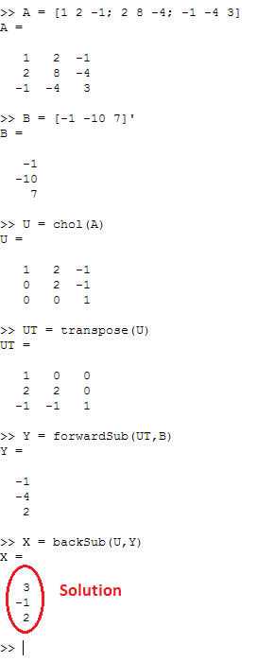3b) 3c)

Backsub function

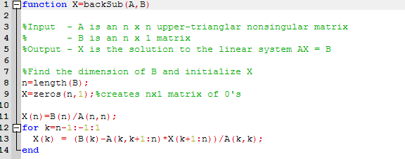

forwardSub function

